Vehicle Sensor Deployment (ASIL-B Annotated)

Competition Vehicle Sensor Layout -- VCU+ROS

Forward-Facing View：

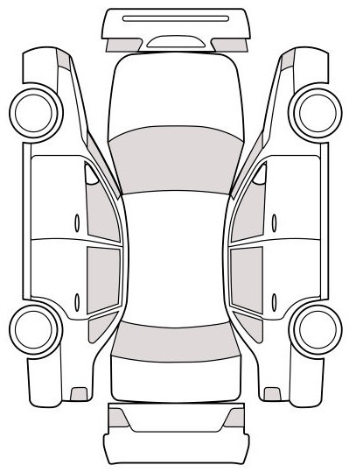 →LiDAR Mounting Location: Roof Rack Assembly

LiDAR @1.2m height → 270° FOV Coverage Obstacle Detection for Emergency Handling

(ISO 26262 ASIL-B Input)

→Camera--IMU Rigid Mounting Location: front windshield

Time Sync: <5ms Jitter

→ VCU Decision Layer Input

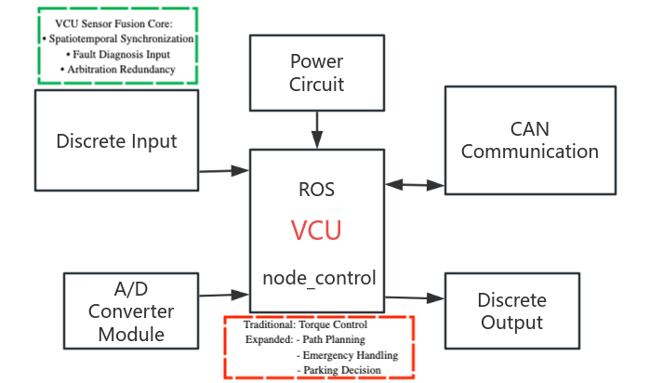

VCU-Centric Autonomous Functions：

* Decision Deployment: Path Planning & Emergency Handling
* Sensor Fusion: Spatiotemporal Sync (<5ms)
* Functional Safety: Fault Diagnosis & Arbitration (ASIL-B)

Note：STM32F4 Platform → 80% Mass-Production VCU Functions

(Aligns with ISO 26262 ASIL-B)